**A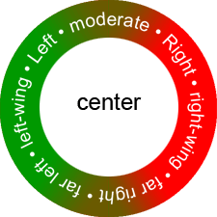P Government and Politics**

***What’s Your Political Ideology??***

Questions often arise as to what is a *liberal*? What is a *conservative*? What does it mean to support the *Left*? Or the *Right*? What does a certain political party stand for? Although positions change over time and it's never good to make generalizations about what a certain group thinks, these quizzes try to pinpoint your place on the political spectrum.

**Directions: Please type this assignment up on a separate sheet of paper.**

1. Do you consider yourself a liberal, conservative, or moderate?
2. What are your political hot button issues? (areas in which you have strong interests)

* Now, select three of the following self-quizzes to find out more about your political beliefs.

IDEALog- Goldman & Janda <http://idealog.org/idealog.asp?ClassID>

Pew Research Group <http://typology.people-press.org/typology/>

Political Quiz-USA Weekend http://franz.org/quiz.htm

Advocates for Self-Government <http://www.theadvocates.org/quiz.html>

Pace News Limited <http://www.politicalcompass.org/>

1. Quiz ___________________________________________________
   1. What did the quiz say about your political ideology?
   2. How accurate do you believe this quiz was? Explain
2. Quiz ___________________________________________________
   1. What did the quiz say about your political ideology?
   2. How accurate do you believe this quiz was? Explain
3. Quiz ___________________________________________________
   1. What did the quiz say about your political ideology?
   2. How accurate do you believe this quiz was? Explain

**After you have taken at least three quizzes and reported your findings, answer these questions:**

1. Which of the quizzes was the most accurate? Explain
2. Which was the least accurate? Explain.
3. What did you learn about yourself from taking these quizzes?